Lab Report Walkthrough: - 5 (2.7.6)

Title: Implement Basic Connectivity Using Two Switches in Cisco Packet Tracer

Addressing Table
Device | Interface | IP Address
S1 | VLAN 1 | 192.168.1.253
S2 | VLAN 1 | 192.168.1.254
PC1 | NIC | 192.168.1.1
PC2 | NIC | 192.168.1.2

Objective
The objective of this lab was to:
- Create a basic switched network topology in Cisco Packet Tracer
- Perform basic configuration on S1 and S2
- Configure IP addresses on PC1 and PC2
- Configure switch management interface (VLAN 1)
- Verify network connectivity
- Save configuration to NVRAM

Part 1: Perform Basic Configuration on S1 and S2

Step 1: Device Placement
The following devices were placed in Cisco Packet Tracer according to the given topology:
- Two Cisco 2960 Switches: S1 and S2
- Two PCs: PC1 and PC2

Step 2: Cable Connections
The devices were connected as follows:
- S1 FastEthernet0/1 → S2 FastEthernet0/1 (Copper Crossover Cable)
- PC1 → S1 FastEthernet0/6 (Copper Straight-Through Cable)
- PC2 → S2 FastEthernet0/18 (Copper Straight-Through Cable)
After connecting:
- All devices were powered on.
- Link indicators (green triangles) confirm active physical connections.
This matches the provided network diagram exactly.
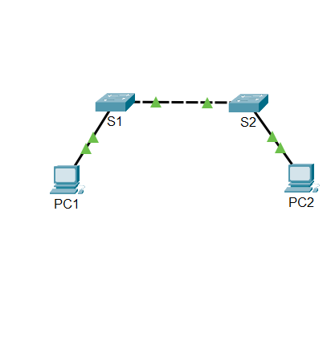

Part 2: PC Host Configuration
In this section, static IP addresses were assigned to both PCs.

PC1 Configuration
- IP Address: 192.168.1.1
- Subnet Mask: 255.255.255.0
- Default Gateway: Not required
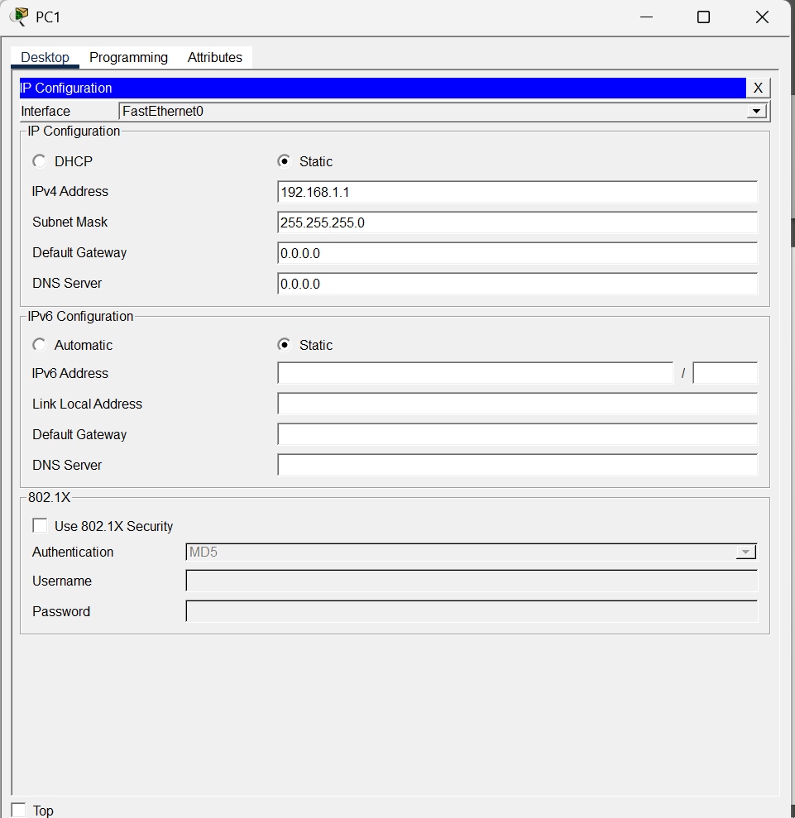

PC2 Configuration
- IP Address: 192.168.1.2
- Subnet Mask: 255.255.255.0
- Default Gateway: Not required
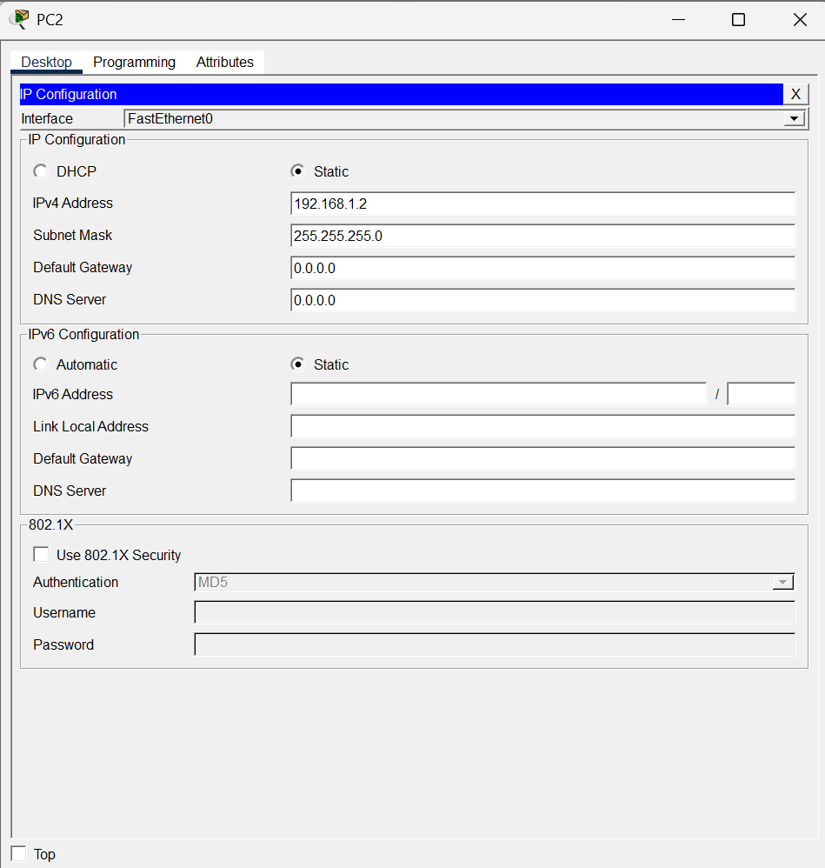

Connectivity Verification (PC to PC)
From PC1 Command Prompt: ping 192.168.1.1
Result:
- First ping may show timeout (ARP process)
- Subsequent pings successful
- 4 packets sent
- 4 packets received
- 0% packet loss
This confirmed successful communication between PC1 and PC2.
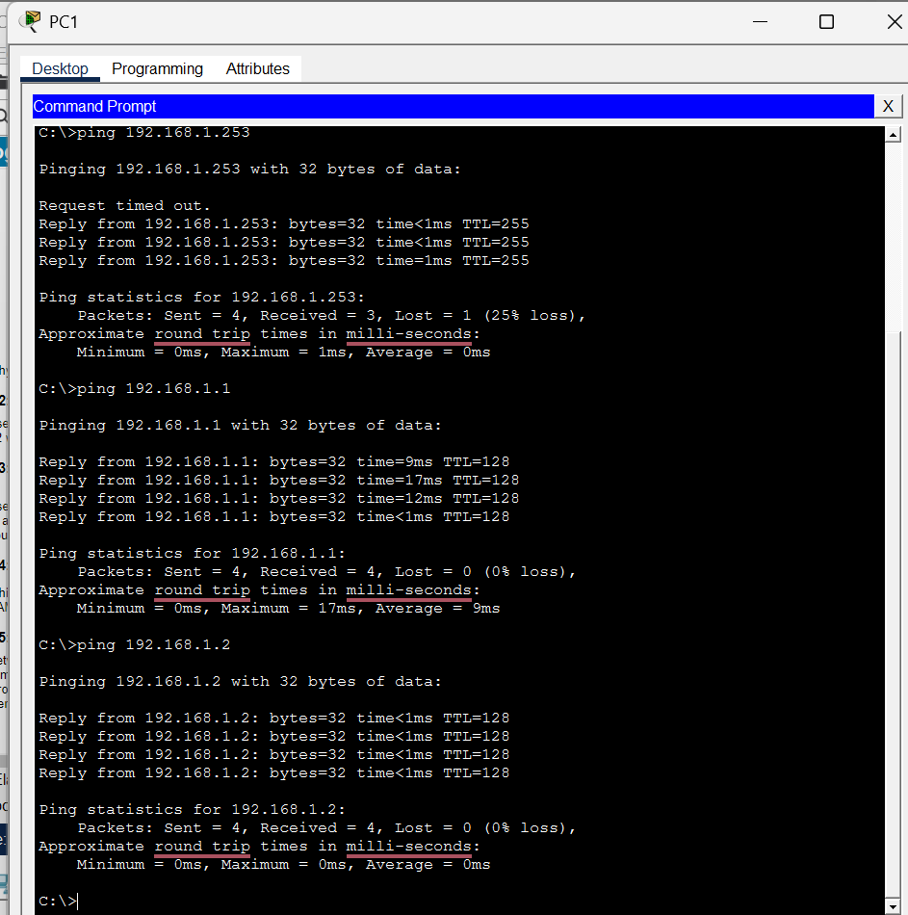

Part 3: Basic Switch Configuration
Both switches were configured through console access.
Step 1: Access Switch CLI
- Connected console cable between PC1and S1.
- Opened Terminal from PC1.
- Entered privileged EXEC mode using: enable

Step 2: Configuration of S1
Entered privileged EXEC mode: enable
Entered global configuration mode: configure terminal
The following configurations were applied:
- Hostname Configuration: hostname SnehaS1
- Enable Secret Password: enable secret class
- Console Password
line console 0
password cisco
login
exit
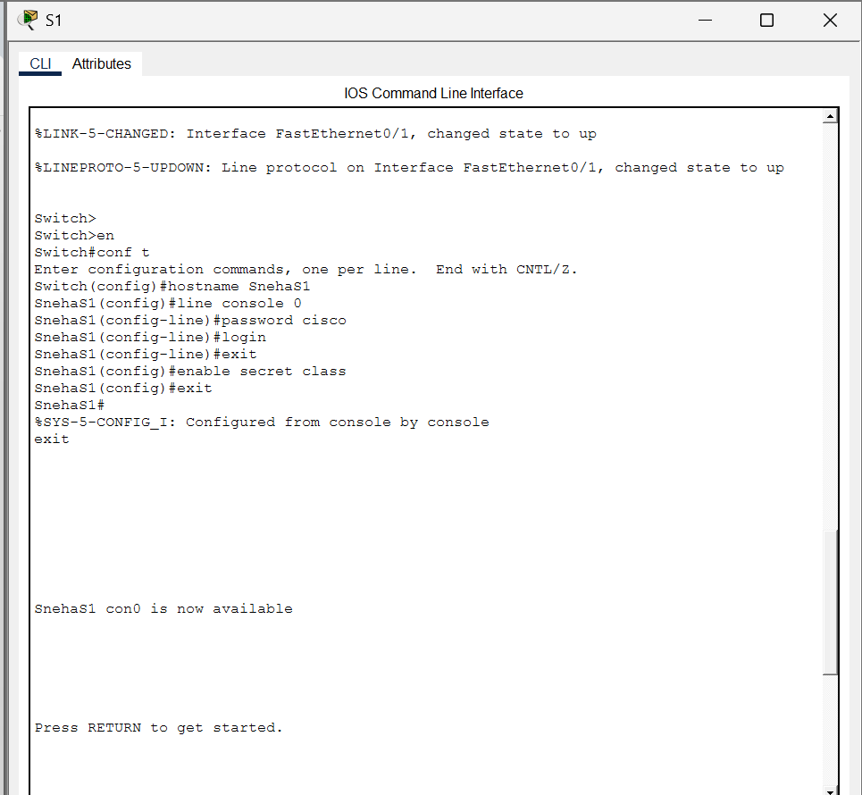

VLAN 1 Interface Configuration
interface vlan 1
Ip address 192.168.1.253 255.255.255.0
no shutdown
exit
The no shutdown command was used to activate the VLAN interface.

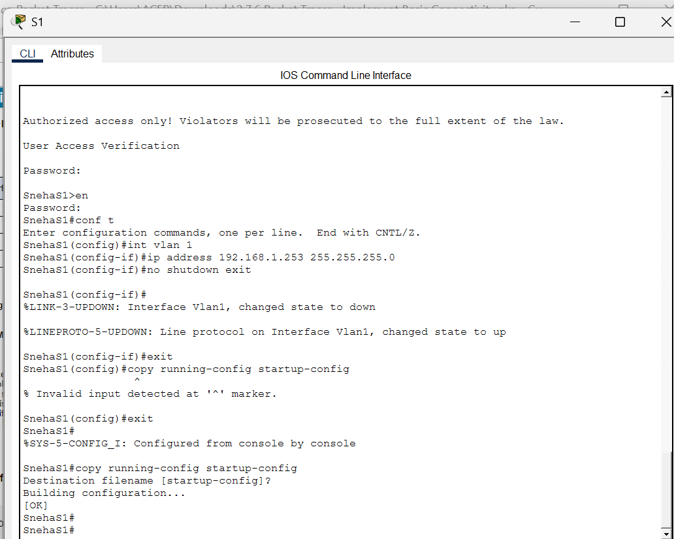
- MOTD Banner Configuration
banner motd #Authorized access only. Violators will be prosecuted to the full extent of the law. #
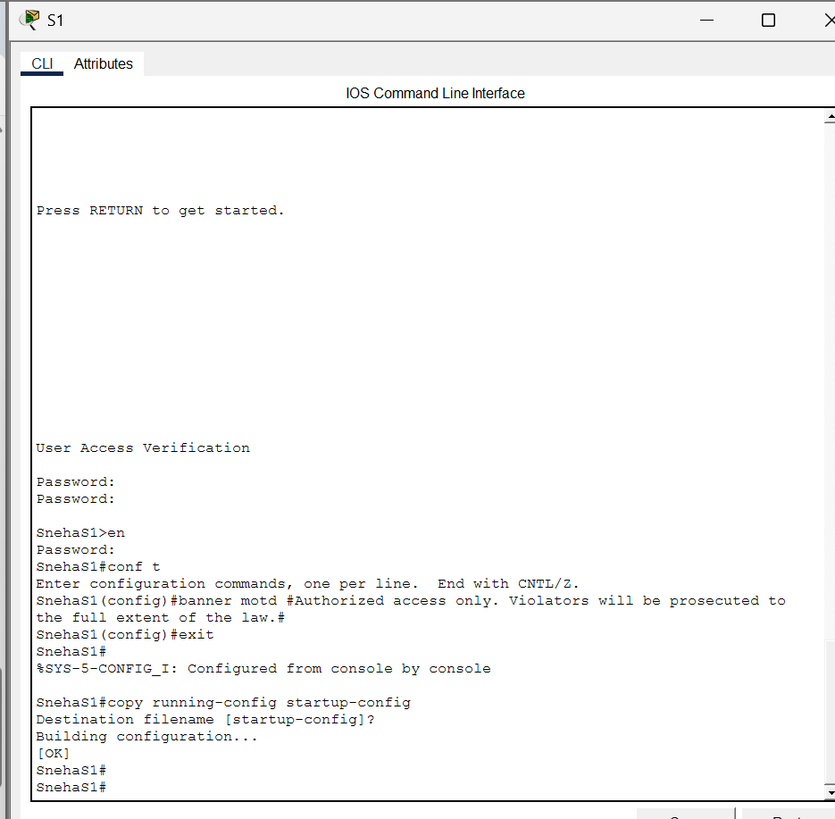
- Save Configuration
end
copy running-config startup-config
Configuration was successfully saved to NVRAM.
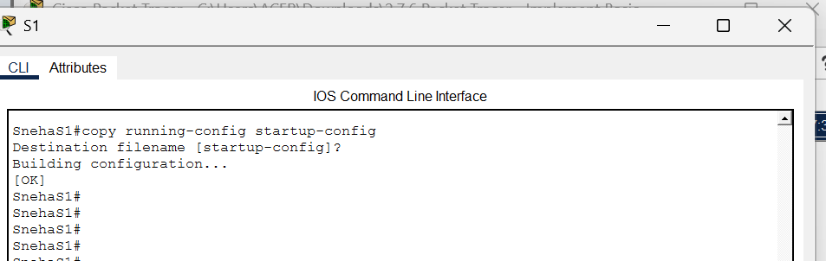

Step 3: Configuration of S2
The same configuration steps were repeated for S2 with the following changes:
- Hostname set to SnehaS2
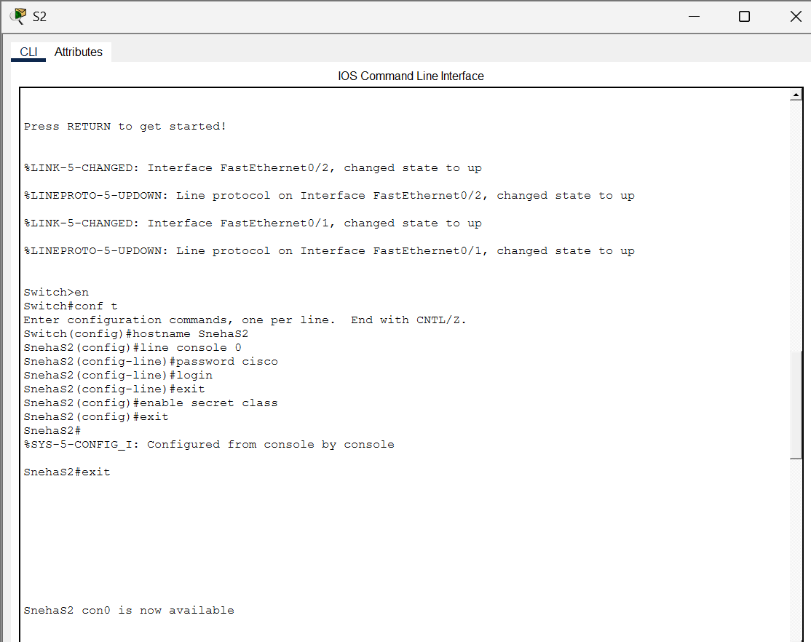
- VLAN 1 IP address configured as:
interface vlan 1
Ip address 192.168.1.253 255.255.255.0
no shutdown
exit
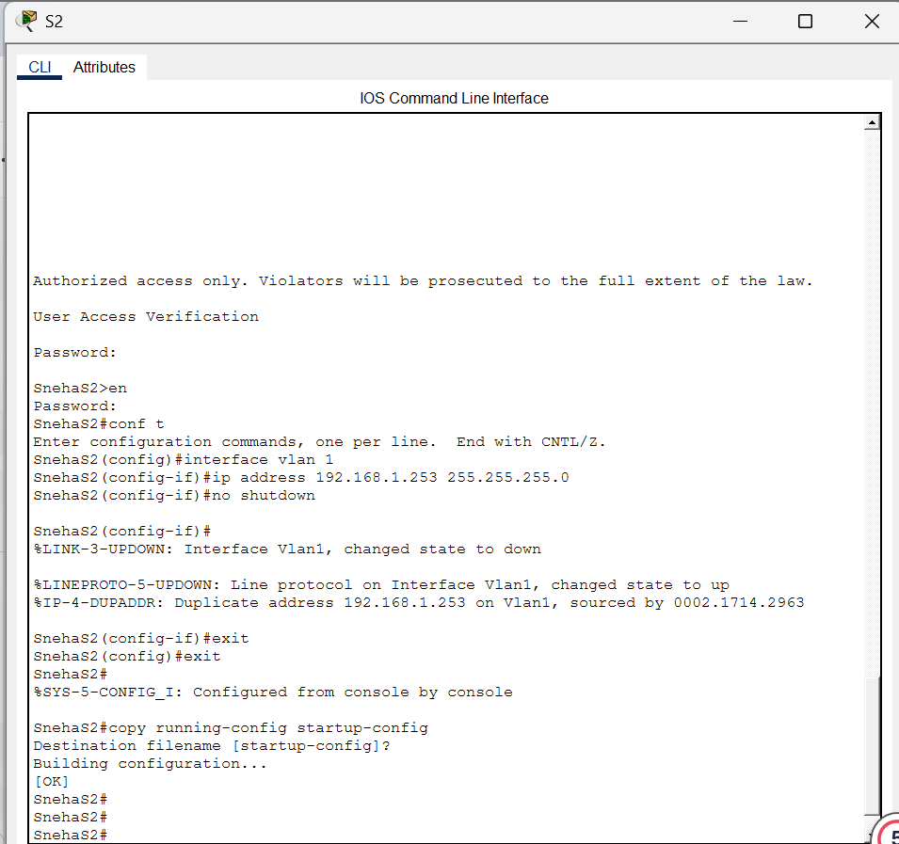
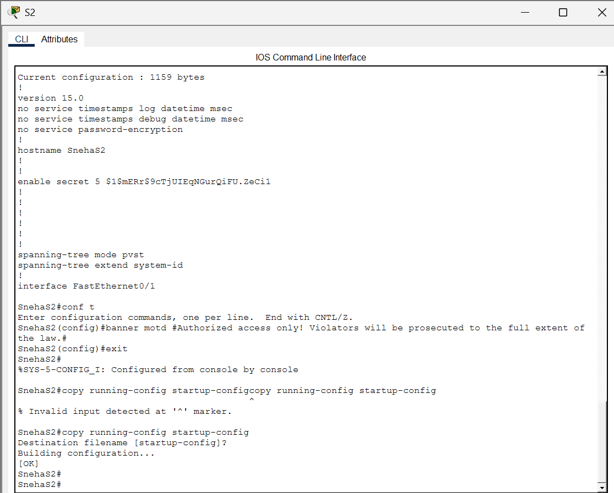
Configuration was saved to NVRAM.

Final Testing and Verification

1. Testing from PC1
ping 192.168.1.2
ping 192.168.1.253
ping 192.168.1.254

Result:
- First ping request timed out (due to ARP resolution).
- Subsequent pings were successful.
- 100% connectivity achieved.
- End-to-end communication verified
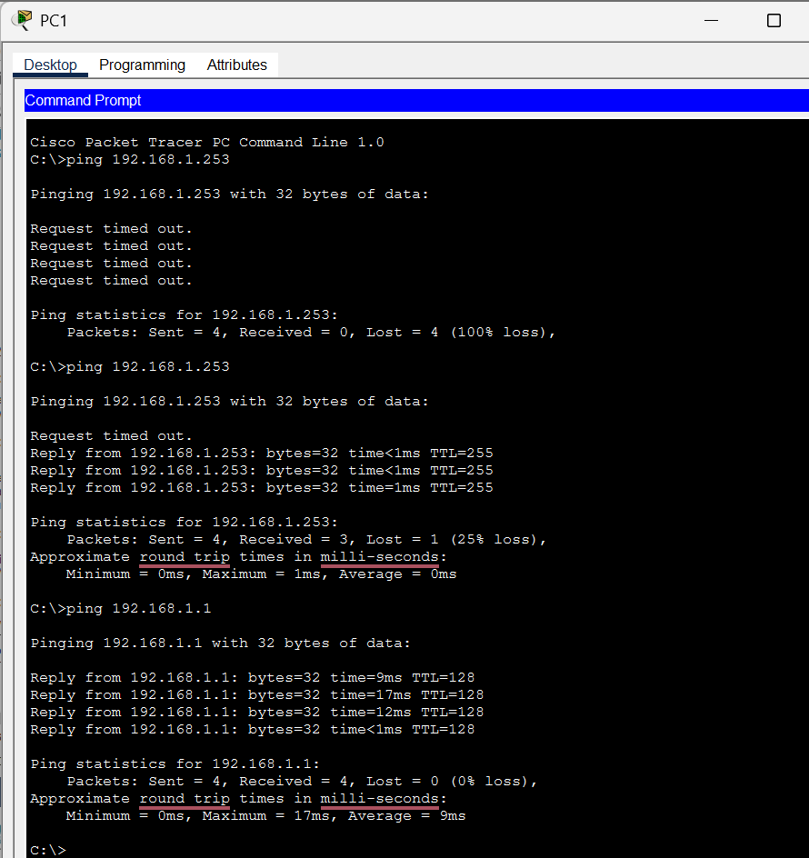

2. Testing from Switch CLI
From switch CLI: ping 192.168.1.1
Result:
- Successful replies received.
- 100% packet success rate.

3. Interface Verification
Command used: show Ip interface brief
Results:
- Connected FastEthernet ports showed up/up.
- Unused ports showed down/down.
- VLAN 1 interface showed up/up status.
This confirmed proper interface configuration.
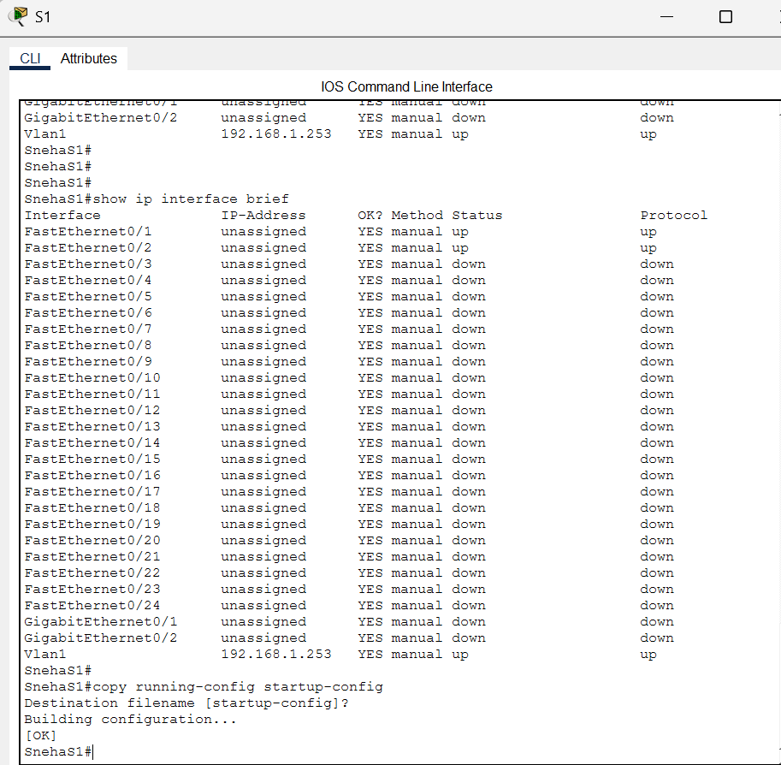
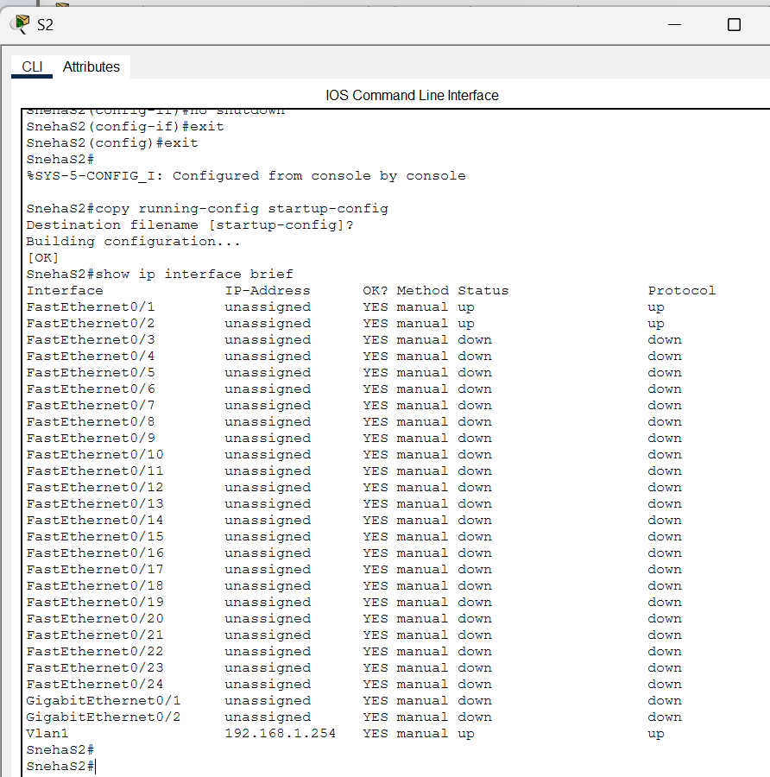

Troubleshooting Performed
During the lab, the following issues were identified and resolved: -
- Duplicate IP address configuration was corrected
- VLAN interface activation issue resolved using no shutdown
- Interface status verified using the show Ip interface brief
- Configuration saved successfully to avoid data loss

Conclusion
The objectives of the lab were successfully achieved: -
- Network topology was correctly implemented.
- Basic switch configurations were properly applied.
- IP addresses were correctly assigned.
- VLAN management interfaces were configured.
- End-to-end connectivity was verified using ping tests.
- Configuration was saved to NVRAM for persistence.
This lab enhanced the practical understanding of:
- Switch basic configuration
- VLAN interface management
- IP addressing principles
- Connectivity verification
- Troubleshooting network configuration issues
The lab was completed successfully.

Reflection Questions: -

How can you verify that both passwords were configured correctly?

To verify that the console password and enable secret password were configured correctly:
- Exit the switch CLI completely using: exit
- Re-enter the switch.
- When prompted, enter the console password (cisco).
- Type: enable
When prompted, enter the privileged EXEC password (class).
If:
- The switch asks for the console password
- The enable command asks for the secret password
- And access is granted after entering the correct passwords
Then both passwords were configured successfully.
Note: - You can also verify using: show running-config
This command displays the configured passwords (encrypted for security).

Which command do you issue to accomplish this step?
The command used to save the configuration from RAM to NVRAM is: copy running-config startup-config

Were you successful? Explain.
Command used from PC1: ping 192.168.1.253

Explanation: Yes, the ping was successful if replies were received. If the first ping failed but the others succeeded, it is normal due to ARP. If all pings failed → There may be an IP configuration issue or VLAN interface problem. A successful ping confirms correct IP configuration, active VLAN interface, and proper physical connectivity.

If switches work without an IP address, why would we configure them with an Ip address?
Switches forward traffic using MAC addresses and does not need an IP address to operate. However, an IP address is configured for remote management, monitoring, and troubleshooting (e.g., ping, SSH, Telnet).
  - Why do you enter the no shutdown command?
The no shutdown command is used to activate (enable) the VLAN interface.
By default, the interface is administratively down, so this command brings it up. Without the no shutdown, the switch will not respond to ping.

Which command saves the configuration file in RAM to NVRAM?
The correct command is: copy running-config startup-config
This saves the active configuration permanently.

